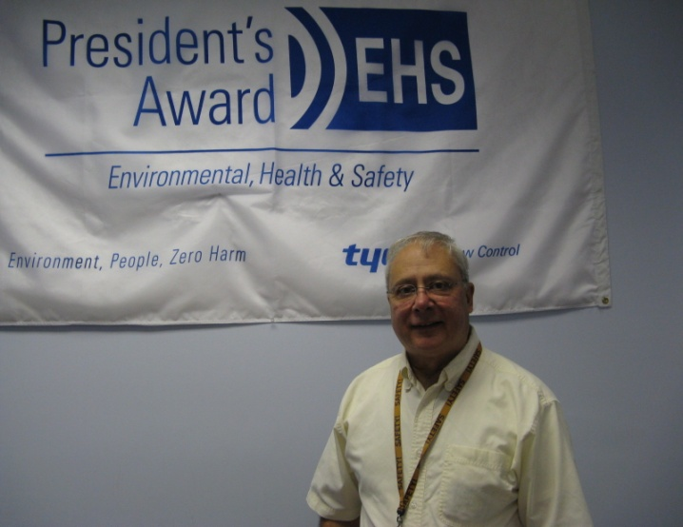

Alan Kerstner is currently the Environmental Health & Safety Manager for Pentair Corporation Westlock Controls formerly Tyco Corporation.
Prior to Westlock Al managed a Critical Parts Test laboratory at Kearfott Guidance and Navigation Corporation.
Al has led Westlock on a journey to achieve Tyco’s President EHS Award for two years, The NJ Governor’s Occupational Safety and Health Award for 8 years consecutively and most recently the OSHA VPP Star site recertification.
In addition Al completed the SGE certification in April 2013 and was appointed to the New Jersey State Industrial Safety Committee in May 2011.
Al has provided VPP mentoring to Tyco, Cintas, Kratos and Pentair facilities.

