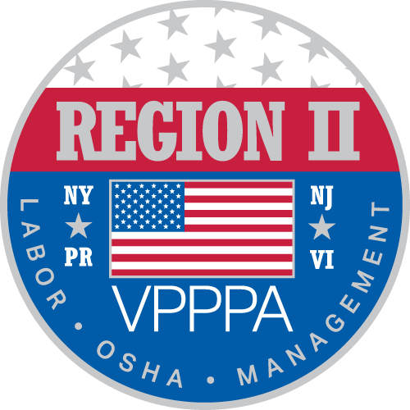

Voluntary Protection Program Participants’ Association ~ Region II Chapter
~~~~~~~~~~~~~~~~~~~~~~~~~~~~~~~~~~~~~~~~~~~~~~~~~~~~~~~~~~~~~~~~~~~~~~~~~~~~~~~~~~
~ Celebrating 27 Years of Excellence in Safety ~

This year is the Region II Voluntary Protection Program Participants’ 27th Year of Excellence in Safety. We are pleased to offer the Safety Forum June 24th and 25th in Atlantic City, New Jersey. For more information on our program, see www.vppparegion2.org.

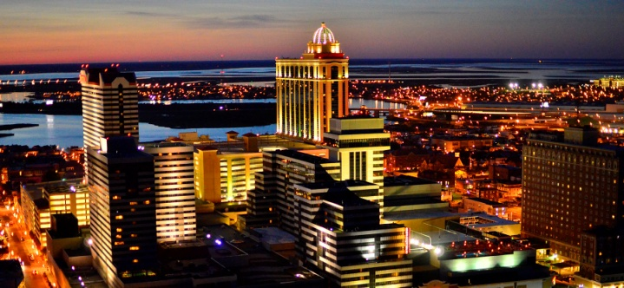
The June 2019 forum will be held at the Tropicana Casino & Resort, 2831 Boardwalk, Atlantic City, NJ.
The safety forum will include a keynote speaker, as well as several speakers and/or organizations represented in the workshops.

LET YOUR COMPANY’S VOICE BE HEARD ~ A LIMITED NUMBER OF BREAKOUT SESSIONS ARE AVAILABLE. THE COST IS $500.00 PER SESSION. YOUR COMPANY WILL LISTED IN OUR MAILER, ON THE WEBSITE & OTHER MEDIA, AND INCLUDED IN THE PROGRAM FOR THE CONFERENCE.

THIS IS A GREAT OPPORTUNITY TO HAVE YOUR BUSINESS IN THE SPOTLIGHT,

TELL US WHAT YOU’RE ABOUT AND BENEFIT FROM

THE NETWORKING AVAILABLE IN THE PROCESS!

WHAT IS VPP? The VPP recognizes employers and workers in the private industry and federal agencies who have implemented effective safety and health management systems and maintain injury and illness rates below national Bureau of Labor Statistics averages for their respective industries. In VPP, management, labor, and OSHA work cooperatively and proactively to prevent fatalities, injuries, and illnesses through a system focused on: hazard prevention and control; worksite analysis; training; and management commitment and worker involvement. To participate, employers must submit an application to OSHA and undergo a rigorous onsite evaluation by a team of safety and health professionals. Union support is required for applicants represented by a bargaining unit. For more information visit us on the web.

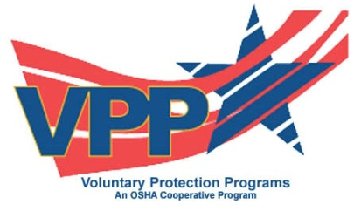
Brenda Wiederkehr, CSC
Director at Large, Region II VPPPA

